Abstract of the audit report Waiting lists at University Medical Centre Ljubljana
The CoA established within the performance audit concerning the management of waiting lists in 2012 that the University Medical Centre Ljubljana was not effective in ensuring equal treatment of patients regarding access to healthcare services.

When reviewing the activities of management of waiting lists of five selected organisational units (clinics or departments), the CoA detected material inefficiencies, ineffectiveness as well as derogations from regulations leading to unequal treatment of patients regarding the access to healthcare services. Waiting lists were kept by different units of the University Medical Centre Ljubljana in distinctly different manners and none of the reviewed units provided for the traceability of changes made, to the lists such as whom by, when and why the changes were made.

The CoA established that 15.2 - 29% of non-urgent patients were examined by medical specialists immediately, not even being listed on the waiting lists, 3.2 - 27.7% of patients were listed on the waiting list but were treated prior to most of the patients with the same degree of urgency. Additional 3.7 - 24.8% of patients were treated as patients coming for a control check-up, even though they should have been regarded as patients waiting for the first specialist examination and listed on the waiting list. The share of patients that were treated preferentially differs between the units as shown in the figure below.

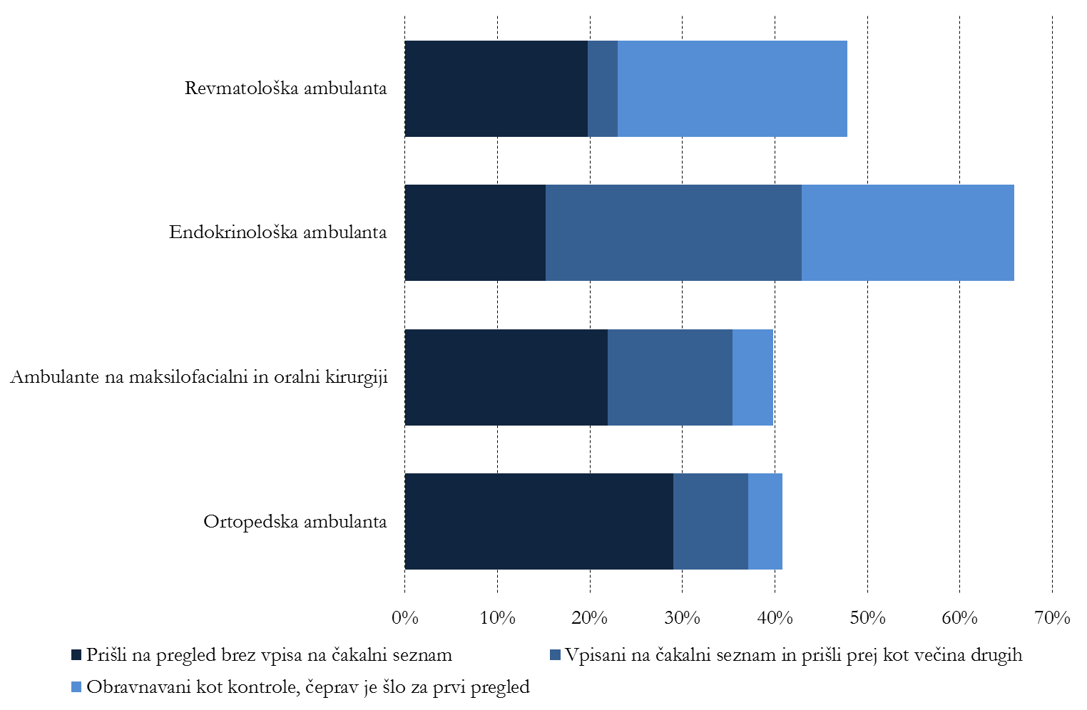
Examination - no prior listing on the waiting list
First specialised examination being considered as control check-up examination
Listed on the waiting list and treated prior to others
Clinics for Maxillofacial and Oral Surgery
Endocrinology Clinic

Orthopaedic Clinic
Rheumatology Clinic

Regarding medical surgeries, the CoA established that 13.9 - 31.3% of non-urgent patients received surgery without being listed on the waiting list or were admitted to hospital prior to most of other patients. The share of patients that received priority surgery is shown in the figure below.

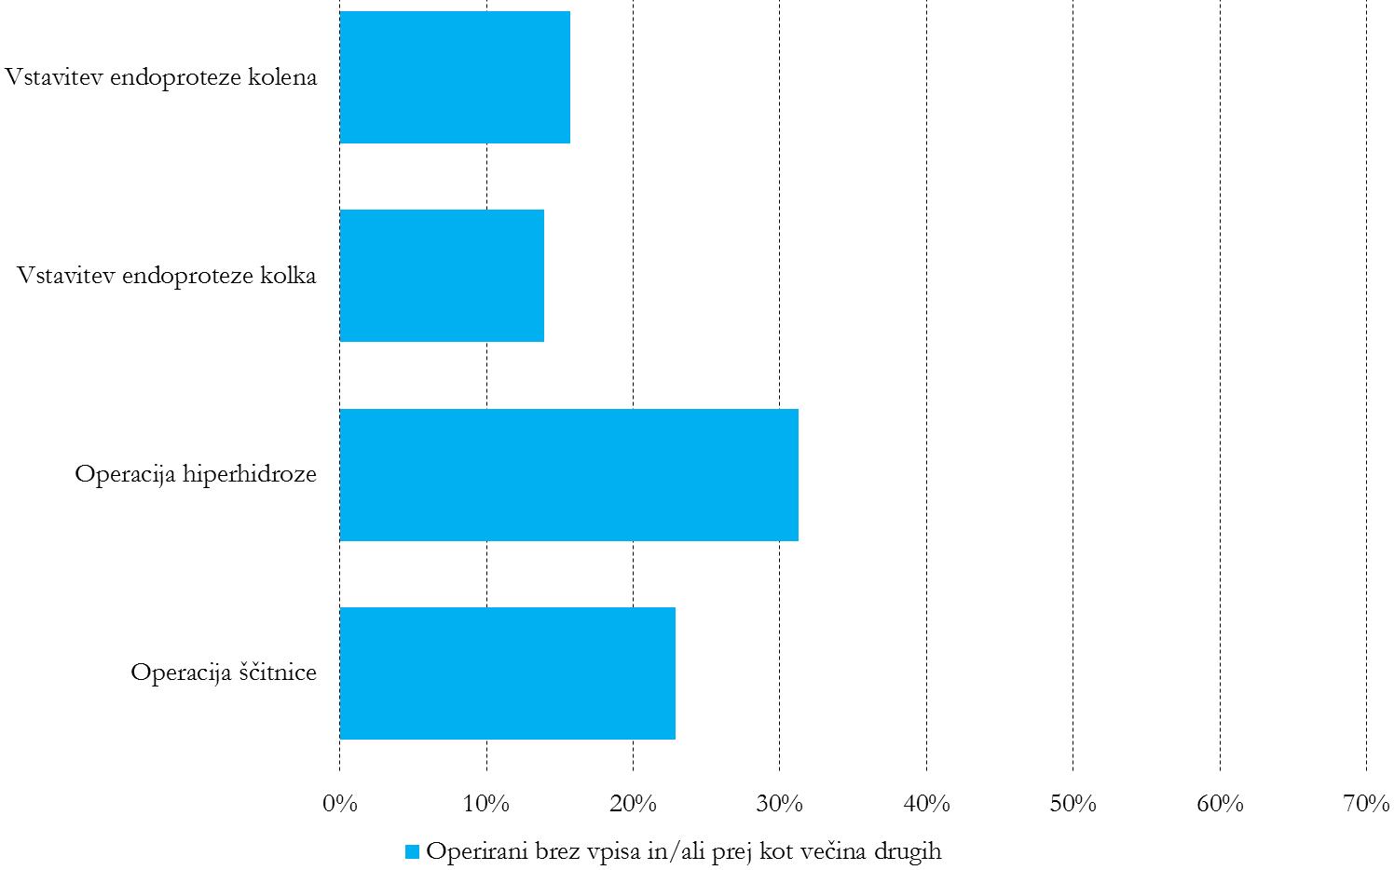
endoprosthetic knee replacement
hyperhidrosis surgery
surgery undertaken without patients being listed on the waiting list and/or prior to most of other patients
thyroid surgery
endoprosthetic hip replacement

Note: Both figures present the share of non-urgent patients that were treated as a priority relative to all patients that should have been listed on the waiting list and treated according to the date of entry on the list.

The CoA among else established that none of the units appropriately managed risks of possible corruptive activities, since they did not prevent the possibility of patients being provided healthcare service directly upon an agreement with the doctors or other employees, and since patients were treated without being scheduled as urgent. At the same time, majority of check-ups and surgery in all units in question have been performed without any reference to the waiting lists. The CoA established that the information systems at the University Medical Centre Ljubljana were not fully facilitating all procedures for efficient and effective keeping of the waiting lists, furthermore they did not have efficient control mechanisms to reduce the known risks for unequal treatment of patients regarding the access to healthcare services, namely to prevent non-urgent patients who were not entered in the waiting list to receive healthcare service, and to provide control over the occurrence of deviations.

The CoA is therefore of the opinion that the management of the University Medical Centre Ljubljana was not efficient in reaching the objective of providing for equal treatment of patients regarding equal access to healthcare services and for control over the keeping of the waiting lists by each unit. Due to the fact that the management of the University Medical Centre Ljubljana did not detect most of the risks for unequal treatment of patients and did not take action to systematically reduce such risks, the CoA submitted several recommendations and demanded from the auditee to implement corrective measures, to prevent unequal treatment of patients in future and to set up appropriate controls over possible occurrence of deviations.

Ljubljana, 12 February 2014

